**Unity Basics (Part 2)**

**LAB # 2**



**Fall 2024**

**CSE-411L Intro to Game Development Lab**

Submitted by: **Ali Asghar**

Registration No.: **21PWCSE2059**

Class Section: **A**

“On my honor, as student of University of Engineering and Technology, I have neither given nor received unauthorized assistance on this academic work.”

Submitted to:

**Engr. Abdullah Hamid**

Date:

**21st December 2024**

**Department of Computer Systems Engineering**

**University of Engineering and Technology, Peshawar**

**Objective:**

In this we lab we will learn how to create terrain, learned about its settings, explored features like painting terrain, raise or lower terrain, we also covered materials, shaders and Unity assets and packages in this lecture.

**Tasks:**

- Open/create a Unity scene

- Create a terrain of size 100x100, height 500

- Set height of terrain to 250 (move to this height)

- Create a few mountains and a river on the terrain

- Download textures like grass, road, mountain and water

- Paint the terrain with them

- Create a water material and apply it to a 3D object like plane and put it on the river to create water effect

- Change the water material shader to transparent

- Create 3 cubes with 3 different materials of solid colors (Red, Green and Blue) place them on the terrain.

- Import the third person package and place the prefab in the scene and play the game and move the person around.

**Output:**

1. Open/create a Unity scene

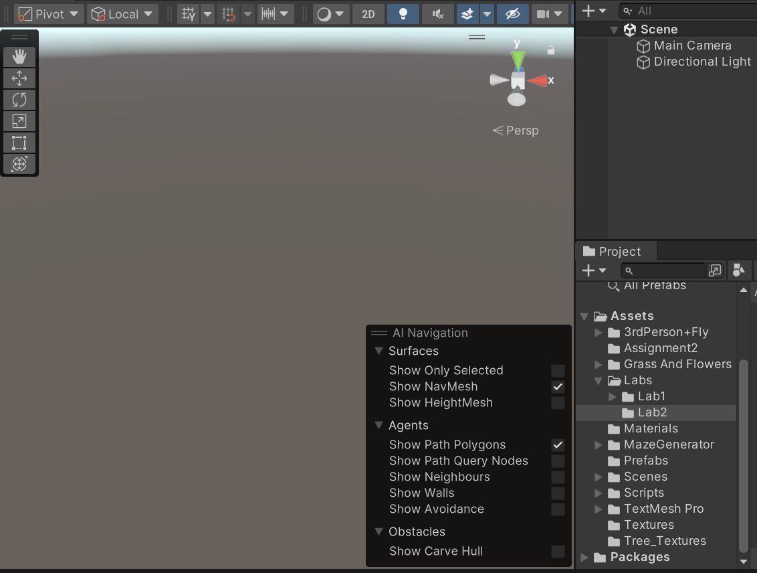

1. Create a terrain of size 100x100, height 500

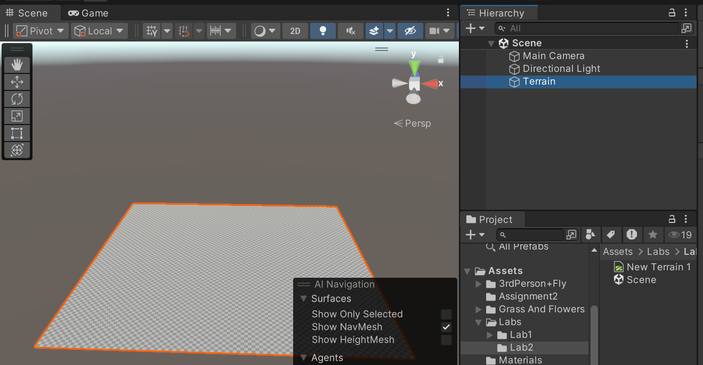

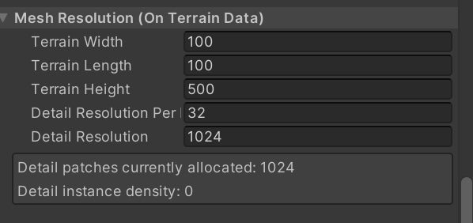

1. Set height of terrain to 250 (move to this height)

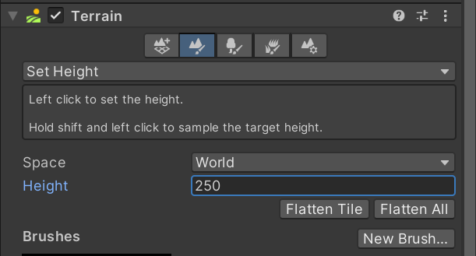

1. Create a few mountains and a river on the terrain

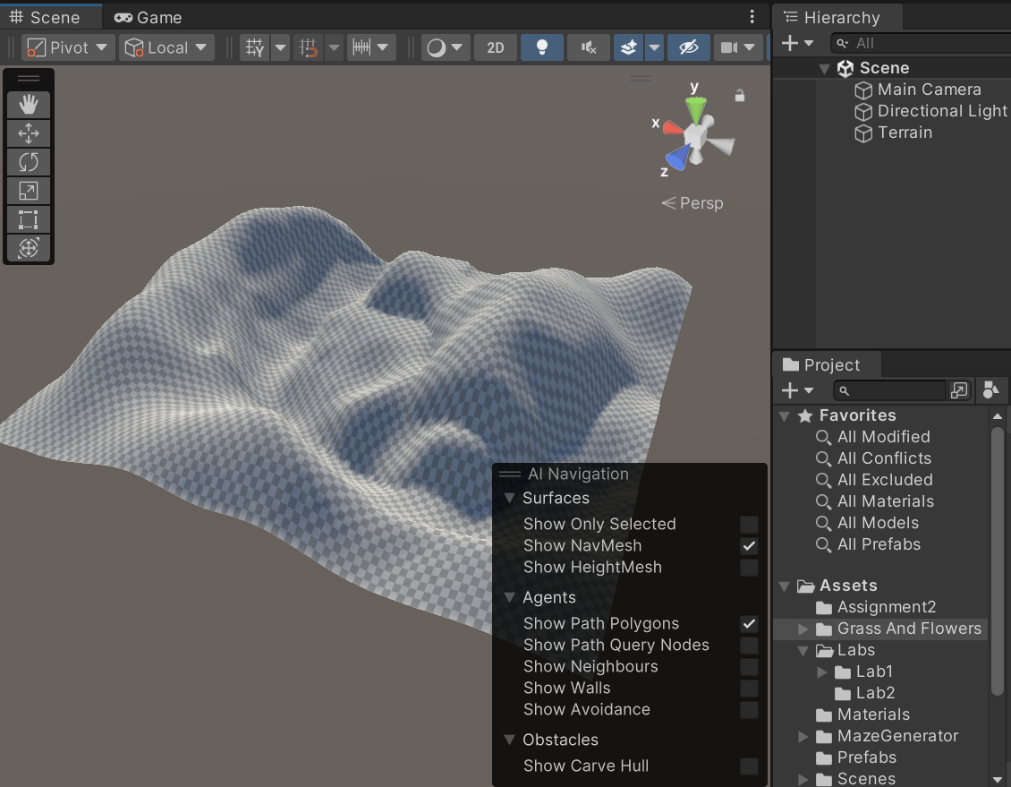

1. Download textures like grass, road, mountain and water

1. Paint the terrain with them

1. Create a water material and apply it to a 3D object like plane and put it on the river to create water effect

1. Change the water material shader to transparent

1. Create 3 cubes with 3 different materials of solid colors (Red, Green and Blue) place them on the terrain.

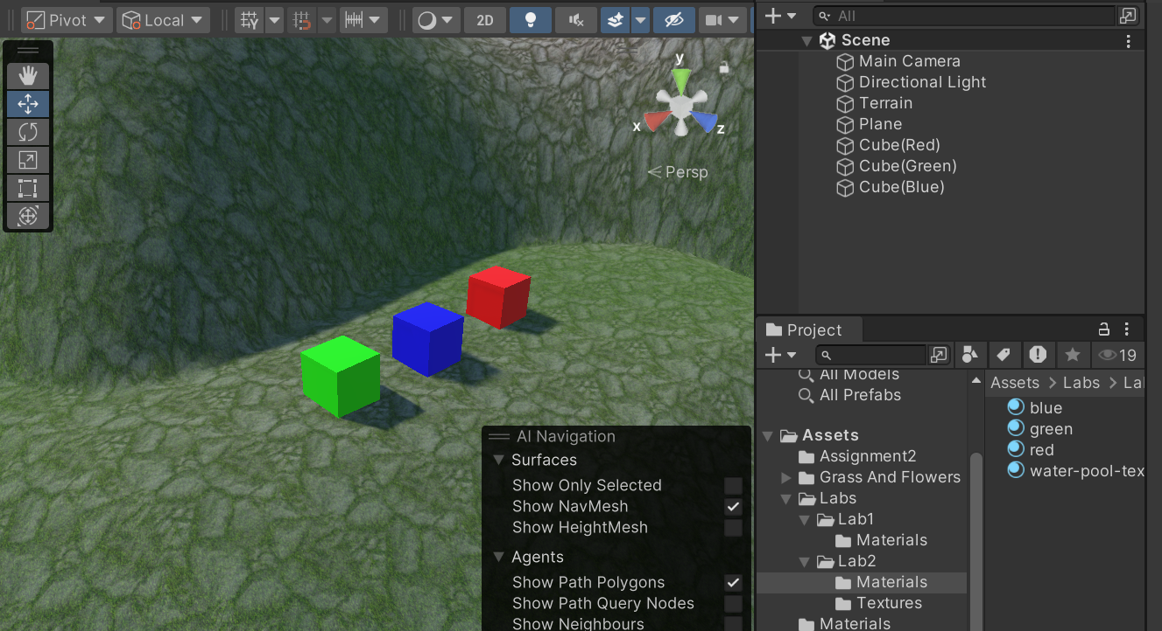

1. Import the third person package and place the prefab in the scene and play the game and move the person around.

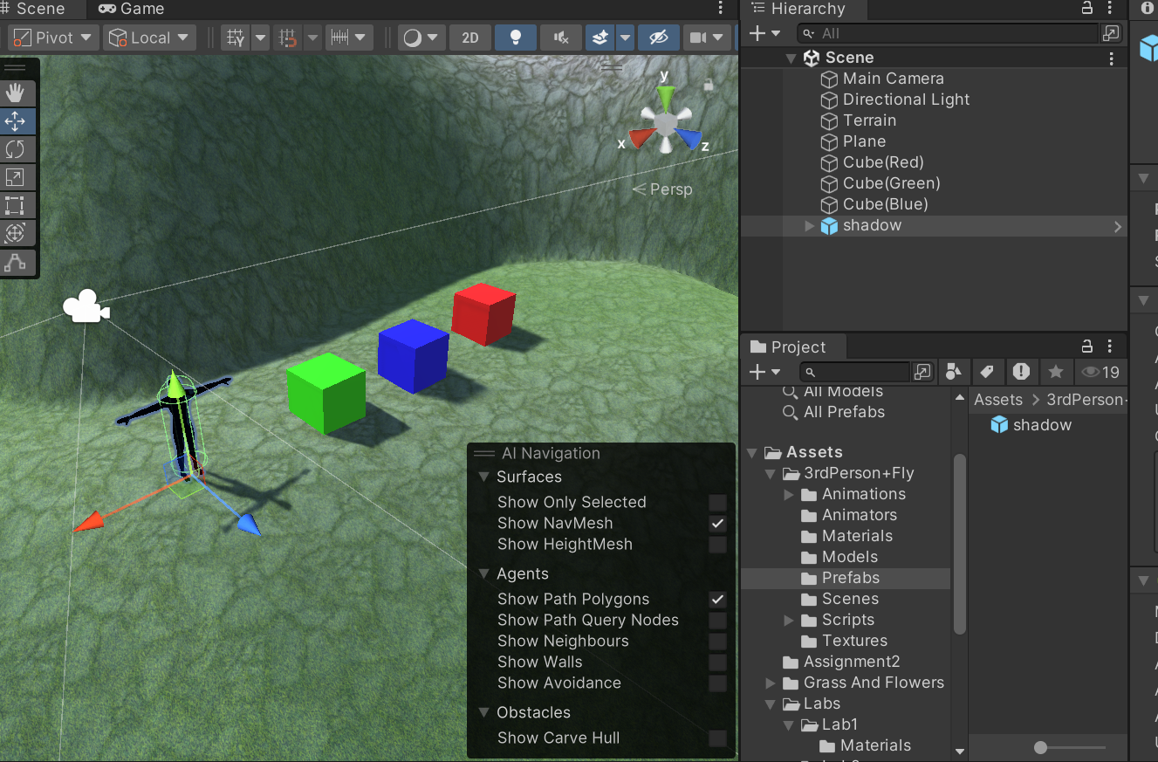

**Final Output:**

